District 12 Leaders Conference - Nice 5-6 October 2012

Program for accompanying persons

Sightseeing tour to Eze & Monaco withDescription : Description : LOGO

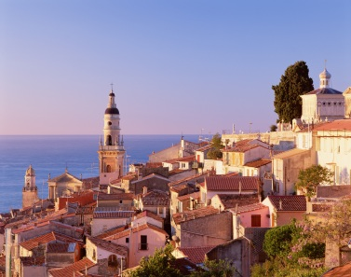

Departure at 10.00 from the Westminster Hotel (Nice): your English/French speaking guide will drive your van by the middle Corniche road to the medieval village of Eze known as the Eagle’s Nest of the Riviera: breathtaking views guaranteed!

**[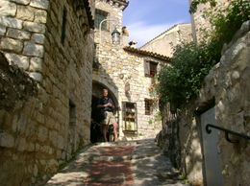](http://www.viator.com/photos/Nice/Eze/d478-567/990599)[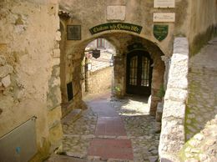](http://www.viator.com/photos/Nice/Eze/d478-567/990603)[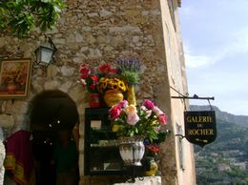](http://www.viator.com/photos/Nice/Eze/d478-567/990602)[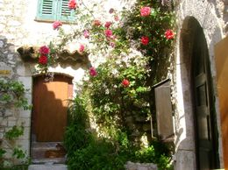](http://www.viator.com/photos/Nice/Eze/d478-567/990597)Eze**: discover the secrets of perfume through the guided tour of a local factory and then visit the tiny village of Eze with narrow cobblestone, pedestrian-only streets. It is one of the jewels of the south of France.

Perched on a rocky hill above the sea, enjoy the wonderful views of the surrounding hills and the azure water below. One of the most famous inhabitants was Frederic Nietzsche who, in the 1880s, used to walk up and down a hill path to the sea thinking up his philosophy.

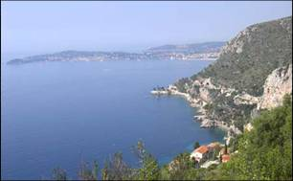

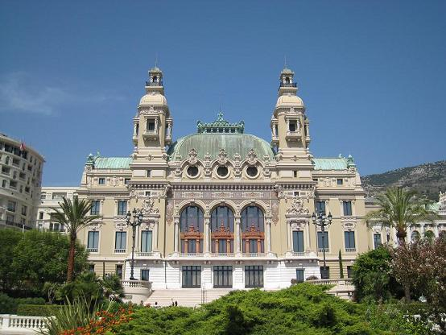Route to Monaco. This tour will also introduce you to the aristocratic gems of the French Riviera, **Monaco and Monte Carlo**.

Ride up to the Rock of Monaco (« Le Rocher ») to see the old town, the Cathedral, Palace Square with the changing of the guard.

Lunch at the restaurant “Le Zest” located on the harbor of Monaco (3 course menu with glass of wine and coffee - choice of site - menu not available yet).

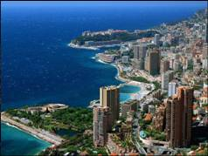Afternoon stroll and shopping in Monte Carlo: you will have some free time to enjoy some luxurious shopping, and stroll amongst the stunning gardens, mega-yachts, and chic casinos… or simply watch the “rich and beautiful” enjoying the good life at their favorite haunts.

Route back by the lower Corniche road to the hotel, arrival at 17.30.

District 12 Leaders Conference - Nice 5-6 October 2012

Program for accompanying persons

Sightseeing tour to Eze & Monaco withDescription : Description : LOGO

Price per person: 135 €

**Participant**

Title

First name

Family name

**Billing Adress (for invoice)**

Street

Zip code

City

Country

Send this form to ISA-France either

by email to [contact@isa-france.org](mailto:contact@isa-france.org)

or by fax to **+33 1 46 52 51 93**

Information: +33 1 41 29 05 05 : Marjorie DEMEULEMESTER